LAB PROGRAM 5
WAP to Implement Singly Linked List with following operations
a) Create a linked list.
b) Deletion of first element, specified element and last element in the list
c) Display the contents of the linked list.

#include <stdio.h>
#include <stdlib.h>

struct node {
int val;
struct node* next;
};

struct node * createsll(struct node *head)
{
struct node *p , *last ;
int ele;
printf("Enter the elements to create a linked list enter -999 to exit:\n");
scanf("%d",&ele);
while(ele!=-999)
{
p = (struct node *)malloc(sizeof(struct node));
p->val = ele;
if(head==NULL)
{
p->next=NULL;
head=p;
last=p;
}
else{
last->next=p;
p->next=NULL;
last=p;
}
scanf("%d",&ele);
}
return head;
};

struct node * deleteAtBeginning(struct node *head) {
if (head == NULL) {
printf("\nList is already empty!\n");

}
struct node *temp = head;
head = head->next;
printf("\nDeleted element: %d\n", temp->val);
free(temp);
return head;
}

struct node * deleteAtEnd(struct node *head) {
if (head == NULL) {
printf("\nList is already empty!\n");

}
struct node* temp = head;
struct node* prev = NULL;

if (temp->next == NULL) {
head = NULL;
printf("\nDeleted element: %d\n", temp->val);
free(temp);

}

while (temp->next != NULL) {
prev = temp;
temp = temp->next;
}

prev->next = NULL;
printf("\nDeleted element: %d\n", temp->val);
free(temp);
return head;
}

struct node * deleteSpecificElement(struct node *head) {
if (head == NULL) {
printf("\nList is already empty!\n");

}

int val;
printf("Enter the value to delete: ");
scanf("%d", &val);

struct node* temp = head;
struct node* prev = NULL;

if (temp != NULL && temp->val == val) {
head = temp->next;
printf("\nDeleted specific element: %d\n", val);
free(temp);

}

while (temp != NULL && temp->val != val) {
prev = temp;
temp = temp->next;
}

if (temp == NULL) {
printf("\nElement %d not found in the list.\n", val);

}
else
{
prev->next = temp->next;
printf("\nDeleted specific element: %d\n", val);
free(temp);

}
return head;

}

void display(struct node *head) {
if (head == NULL) {
printf("\nList is empty.\n");
return;
}
struct node* temp = head;
printf("\nCurrent Linked List: ");
while (temp != NULL) {
printf("%d -> ", temp->val);
temp = temp->next;
}
printf("NULL\n");
}

int main() {
struct node *head = NULL;
int choice;
printf("Create a Linked List:\n");
head=createsll(head);

while (1) {

printf("\nDeletion Operations:\n");
printf("1. Delete at beginning\n");
printf("2. Delete at end\n");
printf("3. Delete specific element\n");
printf("4. Display\n");
printf("5. Exit\n");

printf("Enter choice: ");
scanf("%d", &choice);

switch (choice) {
case 1:
head=deleteAtBeginning(head);
break;
case 2:
head=deleteAtEnd(head);
break;
case 3:
head=deleteSpecificElement(head);
break;
case 4:
display(head);
break;
case 5:
printf("Exiting program.\n");
exit(0);
break;
default:
printf("Invalid choice! Please enter a number between 1 and 5.\n");
}
}

return 0;
}

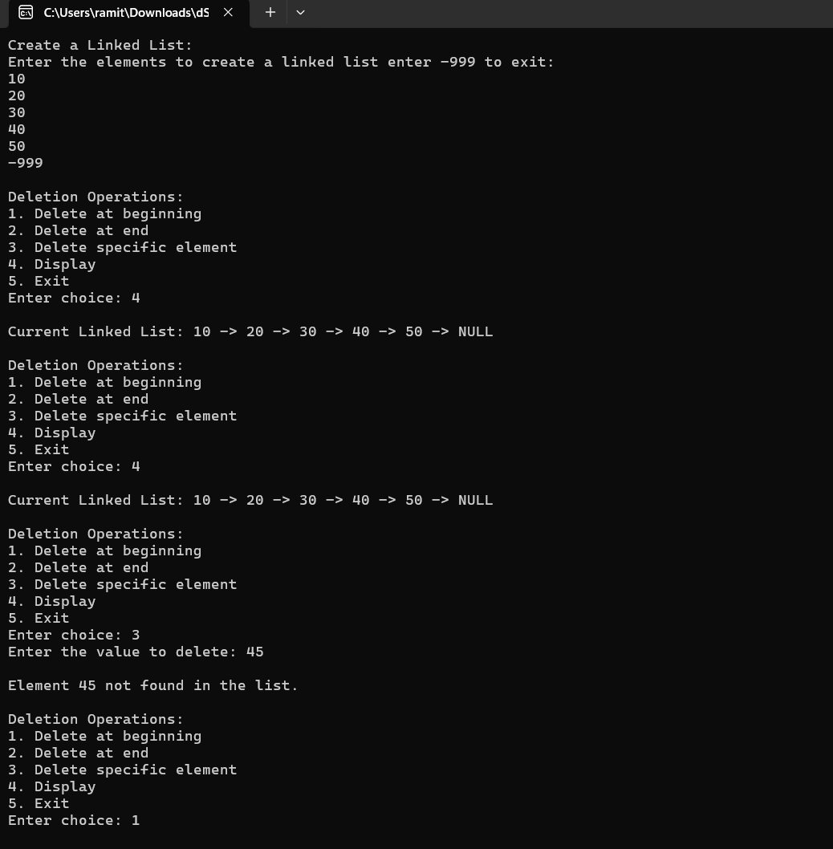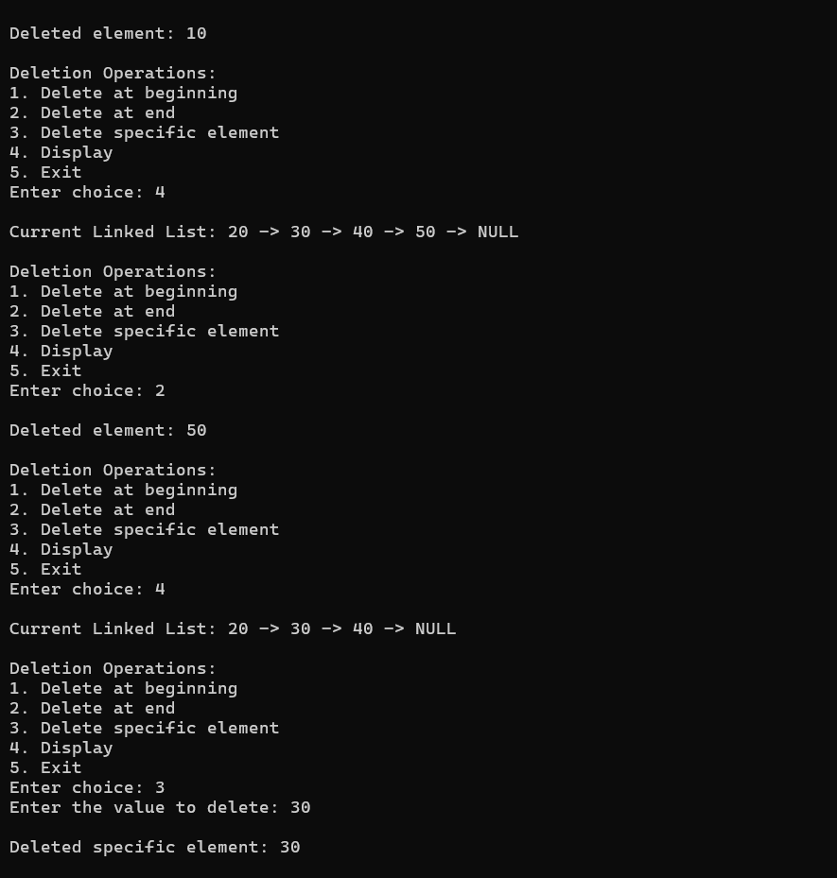
OUTPUT
